About Your Country
Name ________________________________________ Country Name _____________________________________

Directions: Go to the CIA World Factbook (Google it) and find out the following information.
- Locate your country on the map below.

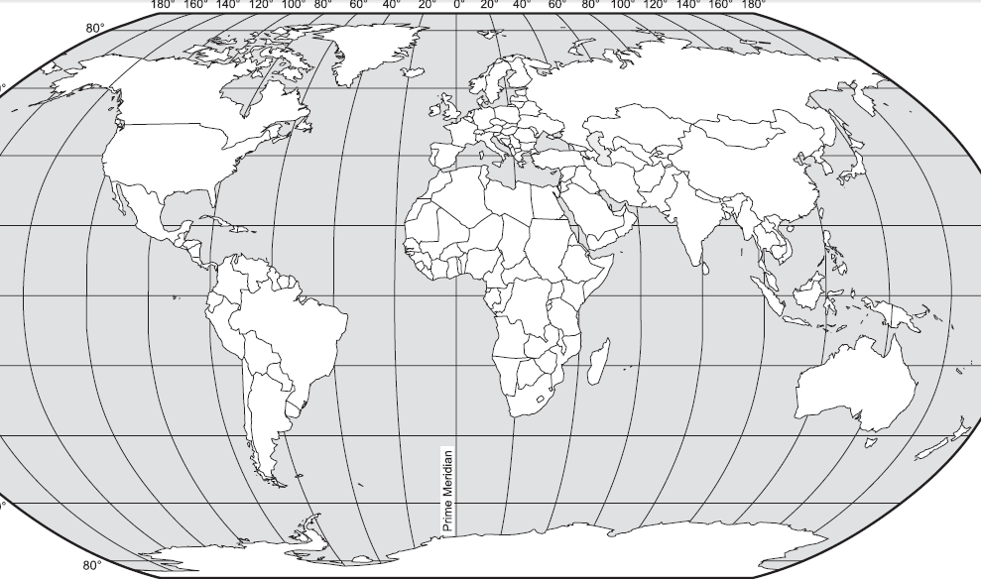

- What is the climate of your country? Any environmental issues? What does this tell you about your country?

- What is your country’s population? Which age group makes up the largest portion of that population? The smallest portion? What does this tell you about your country?

- What is the birth rate of your country? Death rate? Maternal mortality rate? Infant mortality rate? What does this tell you about your country?

- What type of government does your country have? When did it claim independence?

- GDP (Gross Domestic Product) is the amount of money the people in a country make. GDP per capita is the on average the yearly income of the people in your country. What is the GDP per capita of your country?

- What percentage of your country’s population lives below the poverty line?

- From which sectors does your country’s GDP come? Look for GDP – composition by sector. Include percentages.

- What you have: What are your country’s top exports (commodities)? List only the top five.

- What you need: What are your country’s top imports (commodities)? List only the top five.

