Unit 4: Regional Civilizations
The Only Lesson
- Introduction
- Objective: Commercial Revolution
- SOL WHII.5d-e
- Do Now: Read the following excerpt. Then answer the question below.

The voyages of exploration and discovery to Africa and the Americas shifted European trade routes from the Mediterranean Sea to the Atlantic Ocean. This change in trading patterns led to important new economic changes were so great that they have been called the Commercial Revolution.”

Based on this document, what started the Commercial Revolution?

- The Eastern Hemisphere  - Ottoman Empire  - Mughal Empire  - China  - Japan  - Africa | 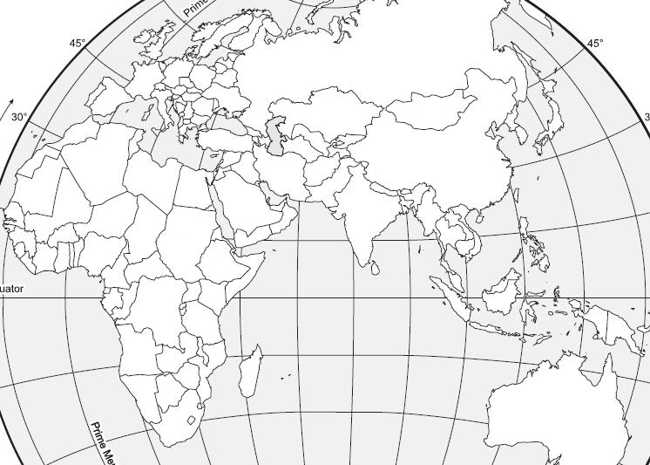

- The Rise of Capitalism
- Defined
- An Activity: Imagine that you were a wealthy capitalist looking to invest $5000 on a voyage. Read the following chart and answer the questions that follow. Note the risk factors include the possible dangers that voyagers faced such as bad weather, pirates, poor ship construction, etc.

Voyager’s Captain | Estimated Length of Trip | Estimated Profit (for every $5000 invested) | Risk Factor  1 (lowest)10 (highest) | % of profit demanded by the King
Chris | 3 years | $1000 | 4 | 10%
Amerigo | 2 years | $5000 | 8 | 10%
Vasco | 1 year | $2000 | 8 | 10%
John | 5 years | $10,000 | 9 | 10%

- Which voyager would you invest your money with? (Remember, maximum profit is your goal!)
___________________________________ because that voyage would earn me a profit of ___________________ per year.
- Which voyager would earn your investment the lowest profit?
___________________________________ would only earn me _____________________ per year.
- Which voyager is the safest investment?
___________________________________ because __________________________________________________________
- What did voyages receive from the King in exchange for a share in their profits?
_____________________________________________________________________________________________________
- What would happen to your investment if the ship sank while on its journey home?
_____________________________________________________________________________________________________

- Commercial Revolution
- Mercantilism
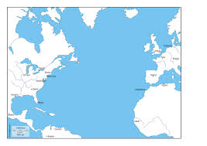
Profits

Manufactured Goods
(iron tools, clothes)

Raw Materials
(iron ore, cotton, furs)

- Commercial Revolution

- Conclusion
- The Ottoman Empire emerged as a political and economic power following the conquest of Constantinople.
- Descendants of the Mongols, the Muslim Mughal (Mongol) rulers, established an empire in northern India. The Mughal Empire traded with European nations. Much of southern India remained independent and continued international trade.
- China and Japan sought to limit the influence and activities of European merchants.
- The exportation of slaves and demand for imported goods began to alter traditional economic patterns in Africa. The Commercial Revolution had an enormous impact on slavery since the colonies needed more labor to support the mother country by providing the raw materials needed.
- European maritime nations competed for overseas markets, colonies, and resources, creating new economic practices, such as mercantilism, linking European nations with their colonies.

Key Terms, Concepts, Events, People, and Places:
Ottoman Empire | Mughal Empire | China | Japan
Foreign Enclaves | Exports | Imports | Mercantilism
Colony | Mother Country | Commercial Revolution
Questions to Consider:
- Where was the Ottoman Empire located, and how did it expand?
- What were the contributions of the Mughal emperors of India?
- What did southern India trade?
- How did the Chinese and Japanese attempt to limit the influence of European merchants?
- How did Africa become involved in foreign trade?
- What were the roles of the Commercial Revolution and mercantilism in the growth of European nations?

