Printing Press
Document Based Question

What are three important consequence of the Printing Press?

Answer the above question in the form of a 5 paragraph essay. Your essay must:
- Have an introduction and conclusion
- Use an outline!! OUTLINE IS DUE THURSDAY OCTOBER 1!! Click on the link “Outline” below the DBQ link on Weebly. Prior to submitting an outline, make sure you have:
- a thesis statement
- an explanation of three consequences you have chosen
- the document(s) you plan on using as your proof.
Remember that an outline only structures your essay. Your final essay will have considerable more information than is asked for in the outline.
- Be typed and printed (you can print to lp1 at the beginning of class if you need to) AND drop boxed (Weebly).
- Use evidence from the documents in packet. You must refer to the document(s) being used by using parenthetical references and referring to the document by its number)
- Use font size no bigger than 12 and no smaller than 10
- Your font choice must be legible – use Arial, Comic Sans, or Times New Roman
- Must be double-spaced!
Your essay is due Friday October 16.

Before continuing with the rest of this packet, define “consequence.” You may think you know what it means but since the success of your essay relies on using the word “consequence” correctly, you are better off defining it first.
There is a questionnaire to use while going through the documents below. I STRONGLY RECOMMEND you use this questionnaire in order to understand the document so that you can use them appropriately. This questionnaire will not be collected but failure to use it is a lack of effort of your part to do the best you can and will be reflected in your final essay. You can find the questionnaire beneath the DBQ link (“Questionnaire.)
Tips on Essay Writing
- Write in complete sentences. Do not use sentence fragments.
- Unless the question asks for your opinion (which this question does not), “I,” “my,” “we,” “our,” and the like do not belong in your essay.
- DO NOT WRITE THE WAY YOU TALK!! Talking is always accompanied by facial expressions and body movements, which do not come with your essay.
- Do not use contractions.
- DO NOT PLAGIARIZE!! Please write in your own words. If you feel the need to quote (which should be used in only rare instances), don’t forget to properly cite the quotation.
Document 1
Source: Advertisement for J. Badius’ film in William of Ockham, Dialogus, (Lyons; J. Trechsel, c. 1494)
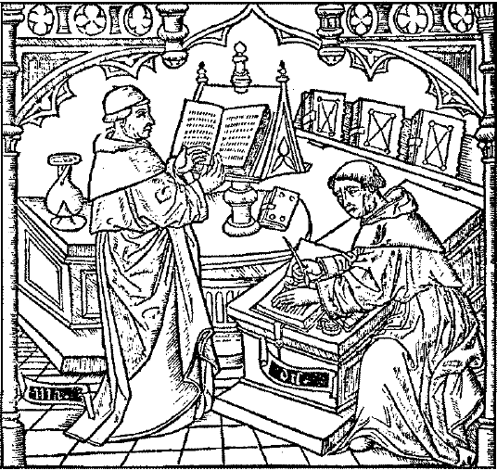
Source: 16th century French manuscript, Un atelier typographique, Bibliotheque Nationale.
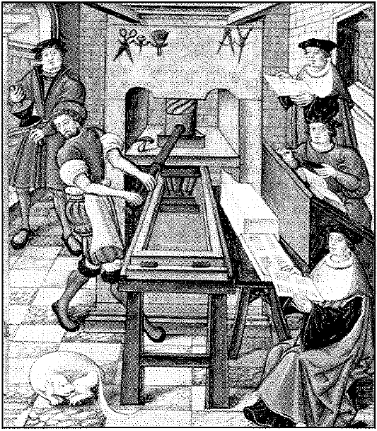

Note: The two images portray the significantly different methods used to produce books before and after Gutenberg’s invention of the printing press. The first woodcut image above is a scribe writing a book by hand from the dictation of a scholar; the second woodcut image above shows a print shop in the mid-1500s.

Document 2
Source: The Spread of Printing. Maps created from various sources
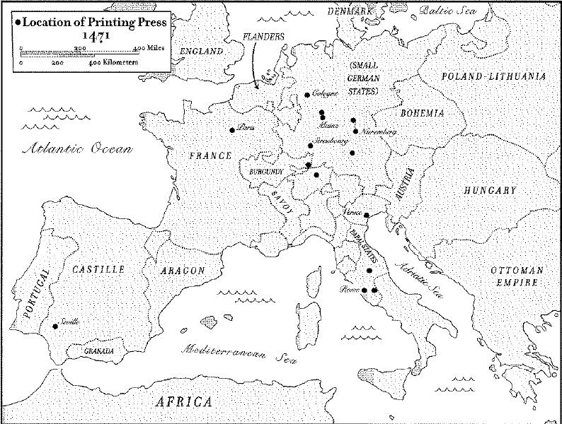
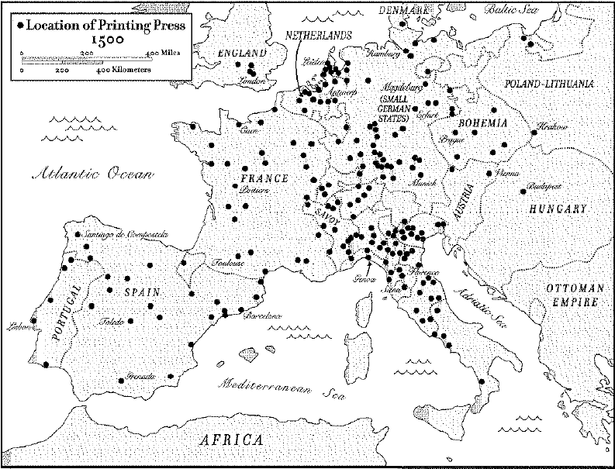

Document 3
Source: Excerpts from Luther’s 95 Theses, 1517.
20. Thus those indulgence preachers are in error who say that a man is absolved from every penalty and saved by papal indulgences.

27. They preach only human doctrines who say that as soon as the money clinks into the money chest, the soul flies out of purgatory.

32. Those who believe that they can be certain of their salvation because they have indulgence letters will be eternally damned, together with their teachers.

45. Christians are to be taught that he who sees a needy man and passes him by, yet gives his money for indulgences, does not buy papal indulgences but God’s wrath.

Note: Martin Luther allegedly posted his 95 Theses on the door of the Castle Church in Wittenberg, Germany, on October 31, 1517. His goal was to stir debate among theologians primarily around the issue of indulgences – payments to the Roman Catholic Church in return for official pardons for one’s sins and grants of salvation in the afterlife. Because of the printing press, the 95 Theses were known throughout Germany in a fortnight and throughout Europe in a month.

Source: John Man, Gutenberg: How One Man Remade the World with Words, 2002
As Rome prepared the heavy artillery, Luther fired off more salvos, with the help of the press. His sermons, tracts, and plemics, all in German… streamed from presses by the hundreds of thousands… According to one estimate, a third of all books printed in Germany between 1518 and 1525 were by him. Pause to consider that figure. Of course, printing was in its infancy, but Germany at the time was turning out about a million books a year, of which a thired – 300,000 – were by Luther. No comparison with the modern world stands up, but it would be the equivalent of one author selling almost 300 million books in Britain (which prints some 800 million a year), or 700 million in the U.S., every year, for seven years running.

Document 4
Arise, O Lord, and judge Thy cause. A wild boar has invaded Thy vineyard… Arise all ye saints, and the whole universal Church, whose interpretations of Scriptures has been assailed.
Papal Bull of Pope Leo X, 1520

If we punish thieves with the gallows, robbers with the sword, and heretics with fire, why do we not all the more fling ourselves with all our weapons upon these masters of perdition, these cardinals, these popes, and all this stink of Roman sodomy that ceaselessly corrupts the church of God and wash our hands in their blood so that we may free ourselves and all who belong to us from this most dangerous fire?
Martin Luther, 1521

Source: Lucas Cranach the Elder. “Passional Christin und Antichristi.” Woodcut, 1521  The woodcut is from a Lutheran booklet. Jesus (on the left) is driving the money-changers out of the temple, in contrast to the Pope, who is writing and collecting on indulgences. Cranach was a close friend of Luther. | 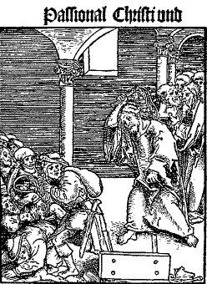 | 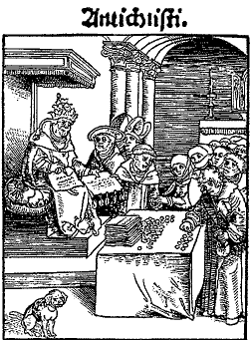

Source: Elizabeth Eisenstein, The Printing Revolution in Early Modern Europe, Cambridge: Cambridge University Press, 1983, p. 158

There is considerable irony about the enthusiastic reception accorded to printing by the church. Heralded on all sides as a “peaceful art,” Gutenberg’s invention probably contributed more to destroying Christian concord and inflaming religious warfare than any of the so-called arts of war ever did.

Document 5
Source: Map created from various sources.

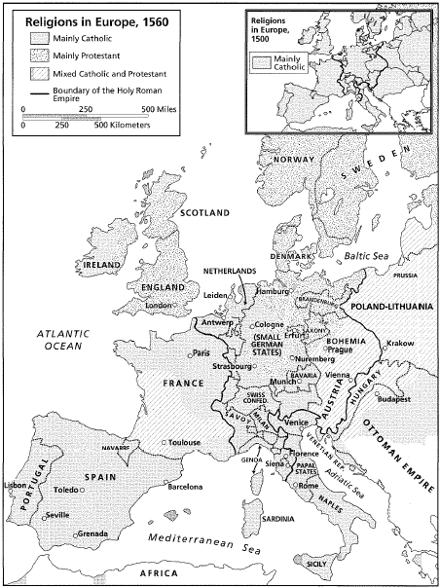

Document 6
Source: Christopher Columbus’ Letter, Concerning the Islands Recently Discovered in the Indian Sea, 1493
Excerpt from Columbus’ 15-page Letter to the King of Spain

Because my undertakings have attained success, I know that it will be pleasing to you: these I have determined to relate, so that you may be made acquainted with everything done and discovered in this our voyage. On the thirty-third day after I departed from Cadiz, I came to the Indian sea, where I found many islands inhabited by men without number, of all which I took possession for our most fortunate king, with proclaiming heralds and flying standards, no one objecting.

Note: Columbus is believed to have written much of the letter on his return voyage from the Americas.

Source: Map created from various sources.
Dissemination of Columbus’ Letter
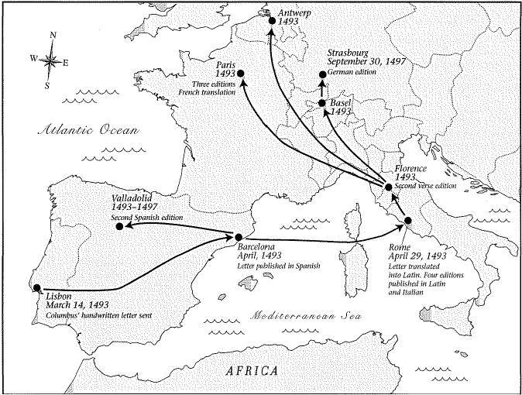

Document 7
Expanding Knowledge of the Globe (3 Printed World Maps)

Source: Henricus Martellus’ World Map, 1489, courtesy British Library |  | 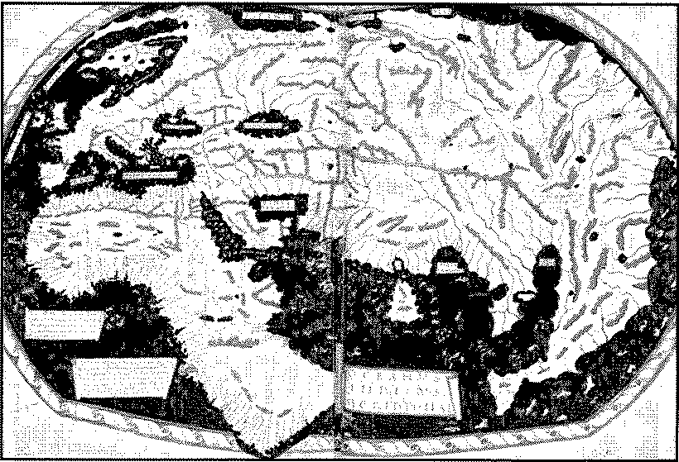
Source: Martin Waldseemuller’s World Map, 15-7, Prints and Photographs, Library of Congress, G3200 ct000725C | 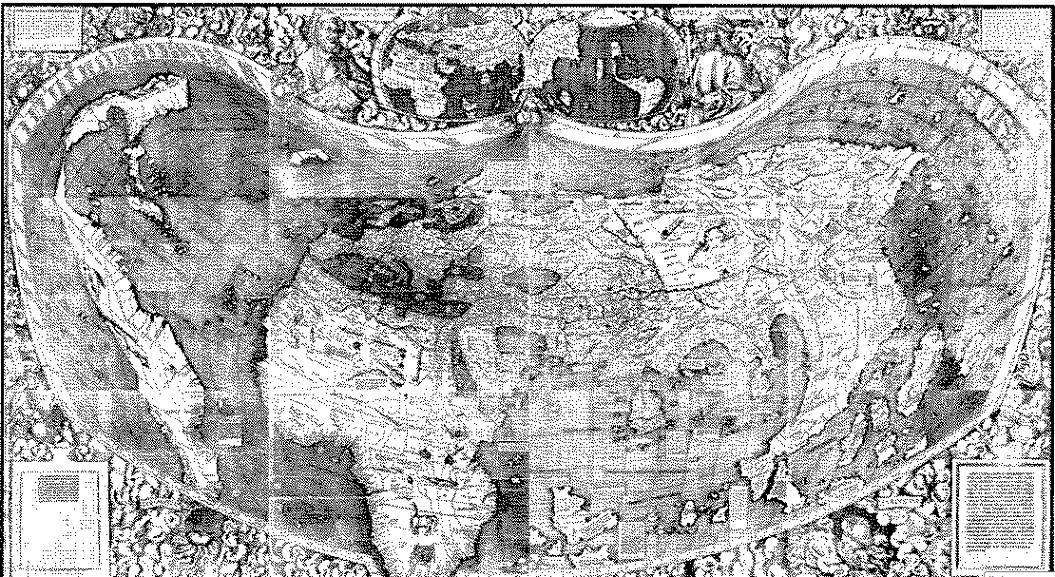
Source: Abraham Ortelus’ 1570 World Map, in Theatrum Orbis Terrarum Prints and Photographs, Library of Congress, G7270 mf00002 | 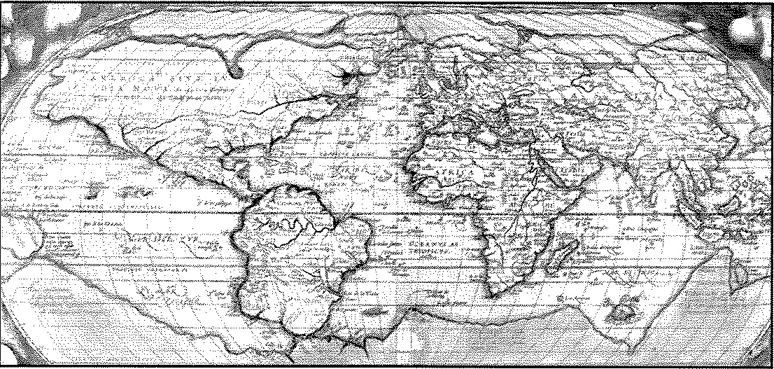

Document 8
Source: John Carter and Percy H. Muir, editors, Printing and the Mind of Man: A Descriptive Catalogue Illustrating the Impact of Print on the Evolution of Western Civilization During Five Centuries, London: Cassell and Company, 1967.
Ten Important Works of Classical and Medieval Authors *
(Date represents first printing)

Homer, Iliad and Odyssey, Florence, 1488/89

Plato, Dialogues, Florence, 1484

Aristotle, Works, Venice, 1495-8

Ptolemy, The Cosmographia, Bologna, Italy, 1477

Herodotus, Histories, Venice, 1502

Virgil, Aeneid, Venice, 1491

Saint Augustine, The City of God, Subiaco, Italy, 1467; and The Confessions, Strasbourg, Germany, 1470

Thomas Aquinas, Summa Theologica, Basel, Switzerland, 1485

Dante, Divine Comedy, Foligno, Italy 1471

Thomas a` Kempis, The Imitation of Christ, Augsburg, Germany 1473

Note: In the 50 years following Gutenberg’s invention, three=fourths of the 20 million newly printed books were classical or medieval works. These books had existed already in scribal manuscript form, but now for the first time were widely available to all who could read. Moreover, as Latin and Greek texts became more well known, publishers began to print the same works in the vernacular (native language), thus expanding the reach of these ancient ideas even further.

*Classical authors dated back to the time of Ancient Greece and Rome. Medieval authors wrote during the several centuries before the invention of the printing press but after the fall of Rome.

Document 9
Source: John Carter and Percy H. Muir, editors, Printing and the Mind of Man: A Descriptive Catalogue Illustrating the Impact of Print on the Evolution of Western Civilization During Five Centuries, London: Cassell and Company, 1967.
Ten Important Works of Early Modern Authors
(Date represents first printing)

Desiderius Erasmus, The Praise of Folly, Paris, 1511

Thomas More, Utopia, Louvain, Belgium 1516

Baldassare Castiglione, The Courtier, Venice, 1528

Niccolo Machiavelli, The Prince, Rome, 1532

Francois Rabelais, Gargantua and Pantagruel, Lyons, five volumes between 1532 and 1552

Georgio Vasari, The Lives of the Most Excellent Painters, Sculptors and Architects, Florence, 1568

Michael de Montaigne, Essays, Bordeaux, France, 1580

Miguel de Cervantes, Dox Quixote, Madrid, 1605

The King James Bible, or the Authorized Version, London, 1611

The Complete Works of Shakespeare, London, 1623

Note: During the first half of the 16th century many works by contemporary writers began to reach a very wide public. For example, historians estimate that several hundred thousand of Erasmus’ works, Adages and Colloquis, were available to the general public within decades of their first printing. Modern and current ideas could then spread more quickly and on a grand scale.

Document 10
Source: Derek T. Whiteside, editor, The Mathematical Papers of Issac Newton I: 1664-1666, cited by I.B. Cohen book review, The Scientific American, January, 1968.
... at the beginning of Newton’s final year as an undergraduate (1664)… he gave up an exclusive diet of reading the ancients… and plunged into the moderns… He read and made notes on Galileo’s Dialoges… and Descartes’ Principles of Philosophy… As we turn the pages of his notebooks we can see his mind leap from summaries of his reading to his own new principles and results… He began to think of gravity as a force extending as far as the moon… In those two years a mathematician was born.

Isaac Newton’s Bookshelf

Source: Charles Coulston Gillespie, editor, Dictionary of Scientific Biograpy, New York: Charles Scribner’s Sons, 1974.

Isaac Newton, the father of the Scientific Revolution, was admitted at the age of 19 to Trinity College, Cambridge, England, on June 5th, 1661. Among the books that he read at Trinity were the following:

Dialogo by Galileo (1564-1642) Italian scientist and philosopher
In this work, Galileo challenges the idea that the earth is the center of the universe and argues that falling bodies fall toward the center of the earth, not the center of the universe.

Dioptrice By Johannes Kepler (1571-1630) German astronomer, physicist, mathematician
In this work Kepler describes how lenses work and applies his ideas to a new kind of astronomical telescope with two convex lenses.

Micrographia by Robert Hooke (1635-1702) English chemist, physicist
Hooke describes his observations through a microscope, and for the first time, accompanies them with illustrations. This was the first great work devoted to this subject.

Geometric and Principles of Philosophy by Rene Descartes (1596-1650) French philosopher
Descartes spells out the foundations of analytical geometry. He is credited with the discovery of this branch of mathematics.

Organon by Aristotle (384-322 BCE) Greek philosopher and student of Plato
This book along with several other Greek classics including Aristotle’s Ethics provides evidence that Newton was well-grounded in Greek rhetoric and logic.

Elements by Euclid (3rd century BCE) Greek mathematician
In this classical work Euclid creates the first systematic geometry based on clarification of such previously undefined concepts as point, line, and plane. Our young scholar Newton is said to have found Euclid “trifling” and put him back in the shelf in favor of a Latin edition of Descartes’ Geometrie.

