Name __________________________________________________
Nationalism: The Unification of Italy
How did an intellectual, a statesman, and a fighter unite Italy?

Italy and the Congress of Vienna

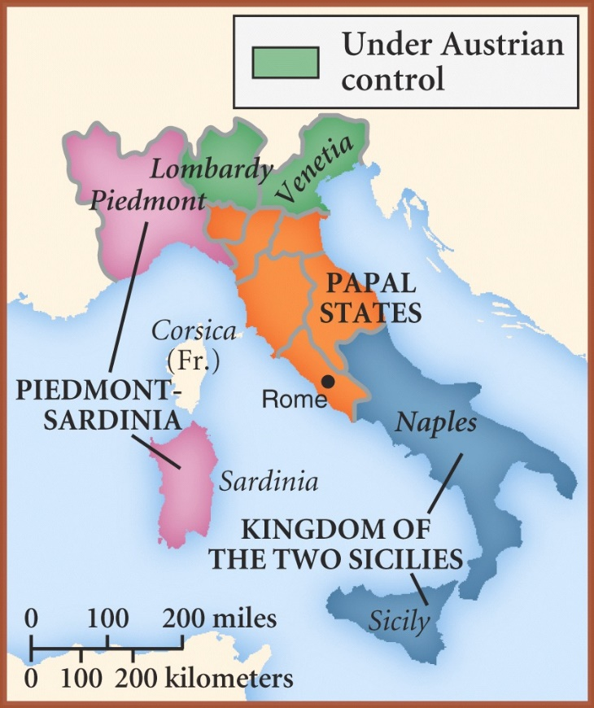 | Following the defeat of Napoleon, the nations of Great Britain, Russia, Austria, Prussia, and France met in Vienna to establish a balance of power. These nations divided up the remainder of Europe to ensure that no one nation would become too powerful. The Congress of Vienna ignored the calls for nationhood from regions such as Germany and Italy.  As a result, Italy was divided into five major states (controlled largely by foreign powers):  - Sardinia (Piedmont): Ruled by King Victor Emmanuel of the Italian House of Savoy  - Papal States: Governed by the Pope and protected by the French monarchy  - Two Sicilies: Ruled by the Bourbon family of France  - Lombardy: Ruled by the Hapsburgs of Austria  - Venetia: Ruled by the Hapsburgs of Austria

Nationalism and Italy

Immediately following the Congress of Vienna, nationalist groups such as the Carbonari began to rally support for a fight against foreign presence in Italy. After failed revolutions in 1821 and 1830, however, it was clear that these groups did not have the support or unity needed to overthrow the existing governments.
After 1830, the nationalists turned to the leadership of Giuseppe Mazzini. Mazzini founded Young Italy, an organization devoted to the unification of Italy. Attempting to rouse Italian nationalism, Mazzini traveled throughout Italy to gain support for a revolution.
In 1848 revolutions did break out all over Italy, but strong foreign forces subdued them. The state of Sardinia was the only one to adopt a more liberal constitution as a result of these revolutions. Although the revolutions failed, Mazzini had advance the idea of a unified Italy and inspired nationalism in many Italians.

Directions:
- Go to Weebly Unit 6 Lesson 3 “The Unification of Italy.” (Site 1)
- Read about the unification process in Italy and the pivotal roles played by Mazzini, Garbaldi, and Cavour.
- Then complete the appropriate sections of Part I on the back.
- Go to Weebly Unit 6 Lesson 3 --? “The 19th Century Unification of Italy.” (Site 2)
- Review the map of Italy and the annotated Italian unification timeline.
- Then complete the appropriate sections of Part I on the back.

Part 1: Chart
Use Sites 1 and 2 to complete both columns of the the following chart.
Name | Contributions to Unification
The Organizer: | - What goals did he pursue in the Young Italy organizations?  - How did “the organizer” contribute to the Italian unification movement?
The Statesman: | - How did he use political alliances to remove the threat of Austria and promote the unification of Italy?  - How did “the statesman” contribute to the Italian unification movement?
The Fighter: | - Who were Garibaldi’s Thousands (also called the “Red Shirts and what path did they take to unite Italy?  - Why did “the fighter” of the Italian unification movement cede political leadership to King Victor Emmanuel?

Part II: Questions
Use Site 2 to answer the following questions.
- What were the five separate states that existed in Italy before unification?

- What is meant by Il Risorgimento?

- What does the following quotation suggest about Italy before unification: “To speak of an Italian people was to speak of a mass of illiterates brutalized by poverty and superstition…”

- What was the last area to join the united Italy in 1870?

Part III: Homework?
It is 1870, French forces leave Italy (to fight in the Franco-Prussian War) and Italians triumphantly declare Rome their united capital. You have been hired by Vittorio Emanuele II, the King of Italy, to write a dedication for a monument honoring the three men who helped to bring about Italian unification. Prepare a dedication (at least one paragraph in length) to accompany the monument. It should highlight the contributions of Mazzini, Cavour, and Garibaldi. The title of your dedication should be the Focus Question: How did an intellectual, a statesman, and a fighter unite Italy?

