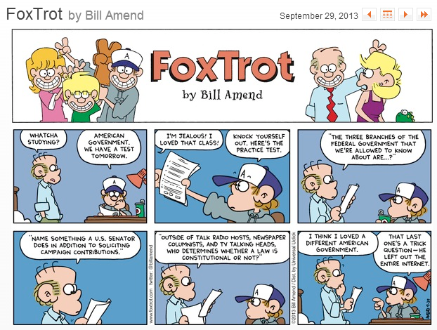 |  |  | AP  Government and Politics  2015-2016
 |  |  | Mrs. Hana Hecht
Course Overview  This course will be an introduction to the study of American government and politics. We will study the historical foundations of American government, comparative philosophies, institutions of American government, policy and policymaking, economics, state and local governments, civil rights and liberties, and foreign policy. The primary purpose of this class will be to prepare you to take the AP exam administered by the College Board in May. (May 10, 2016) Students are graded on a scale of 1-5, with 5 being the highest score. Students who earn a 3 or better may be entitled to college credit, advanced placement in college, or both, depending on the individual policies of the university. It should be understood at the outset that this class reflects a college-level curriculum. As a result, it is a significantly more challenging course than regular courses in American Government. This class will require outside preparation and independent learning.  Basic AP Outline  - Constitutional Underpinnings of United States Government (5-15%)  - Political Beliefs and Behaviors (10-20%)  - Political Parties, Interest Groups, and Mass Media (10-20%)  - Institutions of National Government (35-45%)  - Public Policy (5-15%)  - Civil Rights and Liberties (5-15%) |  |  | Room 220  E-mail: hahecht@henrico.k12.va.us  Office phone: (804) 673-3700  Website: www.rebelrule.com  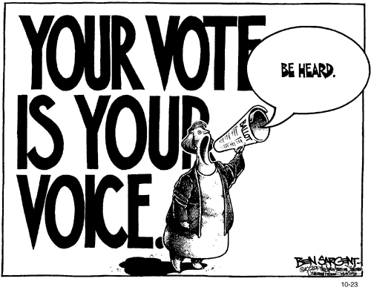
Curriculum  With tentative dates |  |  | 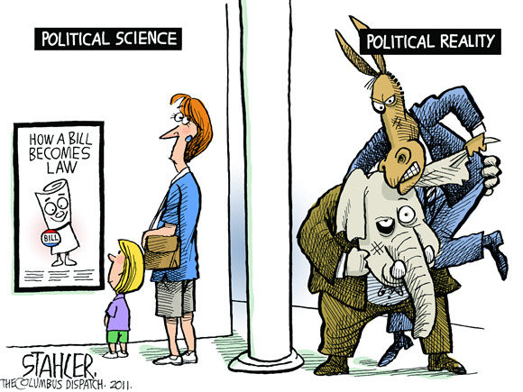
- Unit 1: Foundations of American Government (first half of September)
- Unit 2: The U.S. Constitution (second half of September)
- Unit 3: Federalism (first three weeks in October)
- Unit 4: Civil Liberties (rest of October and first half of November)
- Unit 5: Civil Rights (rest of November)
- Unit 6: The People (December)
- Unit 7: The Legislative Branch (January)
- Unit 8: The Executive Branch and Bureaucracy (first three weeks in February)
- Unit 9: Media and Public Policy (rest of February and first half of March)
- Unit 10: The Judicial Branch (rest of March)
- Unit 11: Elections (first half of April)

Readings
We will be using the Government in America text as our primary textbook. However, like any other college course, we will be reading selected sources including…
- We the People: The Citizen and the Constitution
- The Thirteen American Arguments by Howard Fineman
- What You Should Know About Politics…But Don’t by Jessamyn Conrad
- The United States Constitution (which will be distributed in class)
- Various primary source documents, including the Federalist Papers and Supreme Court decisions
Course Expectations
I expect all students to behave as seniors who are prepared to move into the adult world. As this is a college level course, we expect students to come prepared to do college level work. All students will be expected to devote a portion of time outside of class to completing the assigned readings and/or assignments. Studying is mandatory; students will be required to know facts and definitions as well as understand concepts and philosophical ideas. It is the student’s responsibility to ask for clarification on any points in class which are unclear. Students are reminded that as a study of philosophy and ideas, this class will put their ideas and values in conflict with the ideas and values of others. Students are reminded to be respectful of diversity in the class and to always keep an open mind.

Grading  We will be using total points. Assignments are worth as follows:  Homework = 20 points  Classwork/Participation = 20 points  Quizzes = 25 points  Tests = 100 points (multiple choice is about 75; FRQ is about 25)  Projects = 50-200 points (depends on the assignment) |  |  | 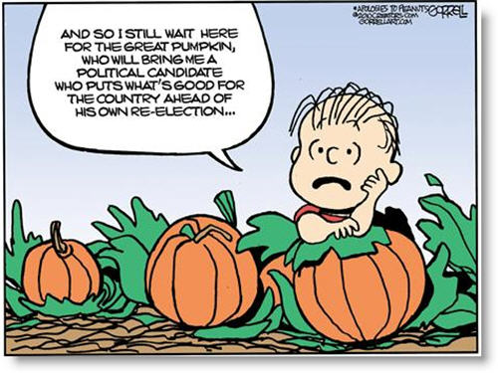
Senior Exam Exemption
Henrico County Public Schools has established an exam exemption policy for seniors. The students must have an 80 cumulative average in the course at the end of the year AND a 4th quarter grade of an 80. A student may not miss more
than ten (10) days from class (excluding religious holidays, field trips, and school related activities). To be counted as present in a class the student must be in attendance for 75% of the period (38 minutes). Three (3) unexcused tardies to class is equal to an absence. Six (6) unexcused tardies to school result in the loss of exam exemption for all classes. Any student who takes an AP Exam, regardless of grade, is exempt from the final exam in that class. The attendance requirement for exam exemption is now necessary, even if you take the AP Exam. THIS IS A CHANGE TO THE POLICY!!!

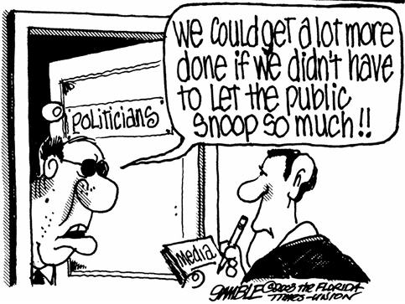 |  | Supplies  - 1 inch (at least) binder with paper  - 1 subject notebook (you may need more)  - Pens – any color but red. No pencils!  - Box of tissues (for the class)

