Unit 12: Independence Movements
Lesson 1
- Introduction
- Objective: Indian Independence
- SOL WHII.14a
- Do Now: Complete the map below using the map on the board.

- II. Independence for Indian Subcontinent  - British Protectorate  - Mohandas Gandhi  - India and Pakistan  - Bangladesh and Sri Lanka  - III, Indian Democracy  - Republic of India  - Jawaharlal Nehru  - Indira Gandhi  - IV. Conclusion  - British policies and India’s demand for self-rule led to the rise of the Indian independence movement, resulting in the creation of new states in the Indian subcontinent. | 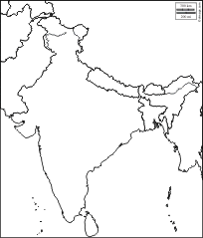
- The Republic of India, a democratic nation, developed after the country gained independence.

Key Terms, Concepts, Events, People, and Places:
Indian National Congress | Mohandas Gandhi | Civil Disobedience | Passive Resistance
India | Pakistan | Kashmir | Bangladesh
Sri Lanka | Ceylon | Caste System | Jawaharlal Nehru
Indira Gandhi | Mixed Economy | East Pakistan | West Pakistan
Questions to Consider:
- Who was the leader of the Indian independence movement and what tactics did he use?
- What were the outcomes of the Indian independence movement?
- Explain the creation of Pakistan, Bangladesh, and Sri Lanka.
- How did the 1950 Constitution set up the Republic of India?
- Was Nehru’s time as prime minister difficult? Why or why not?
- How did Indira further strengthen the Republic of India?
- What major problems did Indira face?

