Unit 12: Independence Movements
Lesson 2
- Introduction
- Objective: Independence in Africa
- SOL WHII.14b
- Do Now: Locate and label the following countries: Algeria, Ivory Coast, Ghana, South Africa, Kenya
II. Independence Movements  - Right to self-determination (UN Charter)  “All peoples have the right to self-determination. By virtue of that right they freely determine their political status and freely pursue their economic, social, and cultural development.”  - After WWII  III. British Colonies  - Ghana (Gold Coast)  - Kenya  - South Africa  - French Colonies  - Ivory Coast (West Africa)  - Algeria  - Conclusion  - The Charter of the United Nations guaranteed colonial populations the right to self-determination.  - Independence movements in Africa challenged European imperialism.  - Loss of colonies by Great Britain, France, Belgium, and Portugal; influence of superpower rivalry during the Cold War. | 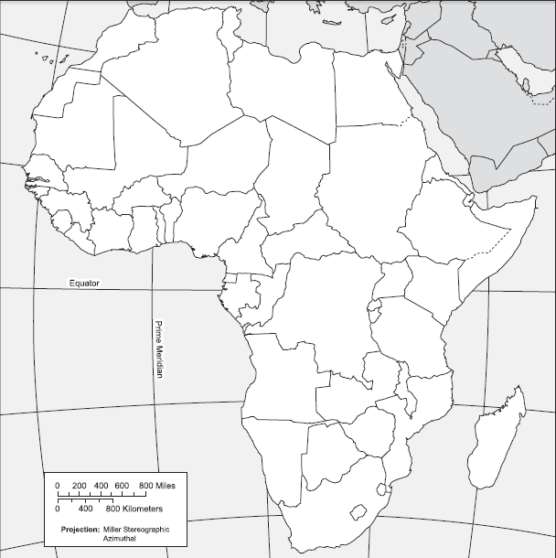

Key Terms, Concepts, Events, People, and Places:
Pan-Africanism | Ghana (Gold Coast) | Kwame Nkrumah | Kenya
Kikuyu | Jomo Kenyatta | Mau Mau | South Africa
Apartheid | ANC | Nelson Mandela | E.W, Klerk
Ivory Coast | French Community | Charles de Gaulle | Algeria
Questions to Consider:
- Why did independence movements in African gain success after WWII?
- What was Jomo Kenyatta’s leadership role in Kenya?
- What was Nelson Mandela’s leadership role in South Africa?
- How was independence achieved by British colonies? French colonies?

