Unit 12: Independence Movements
Lesson 3
- Introduction
- Objective: The Middle East
- SOL WHII.14c
- Do Now: Locate and label: Egypt, Syria, Lebanon, Israel, Jordan, Iraq

- Egypt  - British Rule  - Gamal Abdel Nasser  - French Mandates  - Syria  - Lebanon  - British Mandates  - Transjordan  - Iraq  - Palestine/Israel | 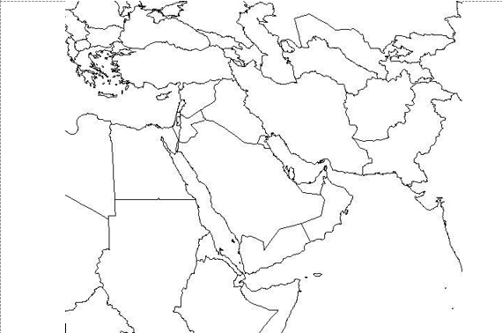

- Conclusion
- The mandate system established after WWI was phased out after WWII.
- With the end of the mandates, new states were created in the Middle East.
- Resulted in Middle East conflicts created by religious differences.

Key Terms, Concepts, Events, People, and Places:
Egypt | King Farouk I | Gamal Abdel Nasser | Suez Crisis
Suez Canal | Aswan High Dam | Syria | Lebanon
Transjordan | Jordan | Iraq | Palestine
Israel | Mandate System | Six Day War | Sinai Peninsula
West Bank | Golan Heights | Yom Kippur War | Camp David Accords
Anwar Sadat | Golda Meir
Questions to Consider:
- What were the results of the United Nations’ decision to end the mandate system in terms of states created (locations) and their subsequent problems?
- What was the role of Nasser in the development of Egypt?
- What was the role of Golda Meir in the creation of Israel?

