Unit 13: Contemporary World
Lesson 4
- Introduction
- Objective: Conflict in Africa
- Do Now: Look at the part of Africa on the map below.
- Which countries are highlighted?
- What other name does this group of countries go by?
- Why do you think it goes by this name?

- Who Is Involved?  - Countries  - Peoples  - Conflict  - Cold War  - Violence  - An End?  - Resolution  - Current Status | 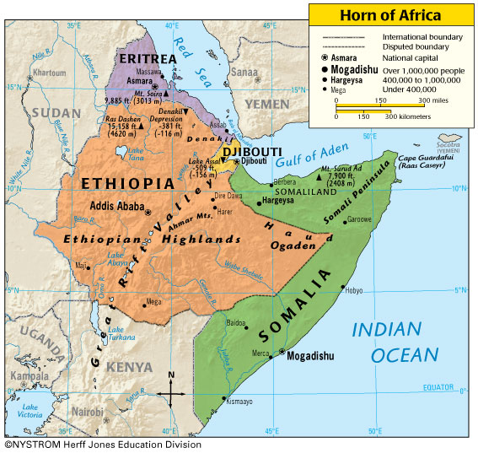

- Conclusion
- The contemporary world faces many challenges, including conflict in Africa.

Key Terms, Concepts, Events, People, and Places:
Horn of Africa | Ethiopia | Somalia
Questions to Consider:
- Is the conflict in Africa an ethnic conflict or a religion conflict? Explain.
- How does the conflict in Africa present a challenge to the contemporary world? Explain.

