Unit 13: Contemporary World
Lesson 5
- Introduction
- Objective: Conflict in South Asia
- Do Now: Find the following countries on the map below:
- Philippines  - Burma (Myanmar)  - Indonesia  - Laos  - Cambodia | 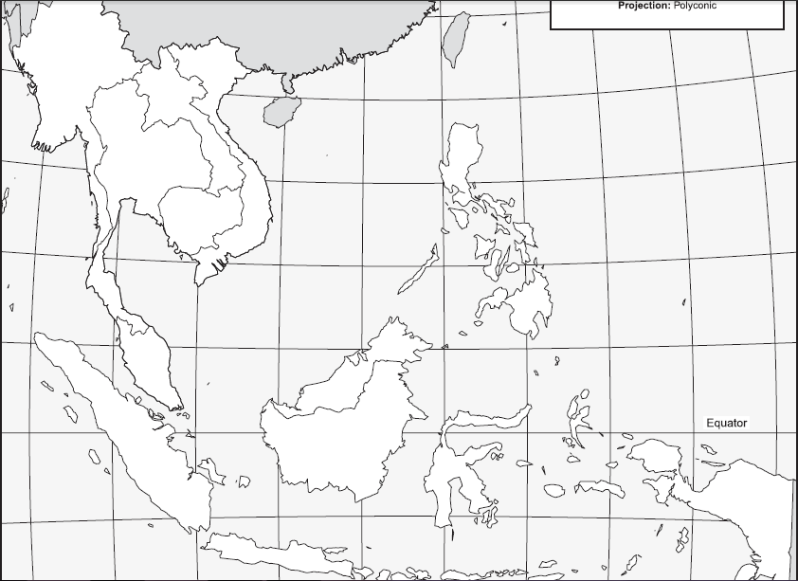

- Philippines
- Who Is Involved?
- Background
- Conflict
- Resolution
- Current Status

- Burma (Myanmar)
- Who Is Involved?
- Background
- Conflict
- Resolution
- Current Status

- Indonesia
- Who Is Involved?
- Background
- Conflict
- Resolution
- Current Status

- Laos and Cambodia
- Who Is Involved?
- Background
- Conflict
- Resolution
- Current Status

- Conclusion
- The contemporary world faces many challenges, which include ethnic and religious conflicts.
- The migrations of refugees and others as a result of these conflicts has become an international conflict.

Key Terms, Concepts, Events, People, and Places:
Philippines | Ferdinand Marcos | Burma | Myanmar
Indonesia | Laos | Cambodia | Migrations
Refugees
Questions to Consider:
- Which ethnic conflicts present a challenge to the contemporary world? Explain.
- Which religious conflicts presents a challenge to the contemporary world? Explain.
- From where are the refugees migrating and what effect has this had?

