Unit 6: 19th Century European Nationalism
Lesson 2

- Introduction
- Objective: The Congress of Vienna
- SOL WHII.8a
- Do Now: Explain what it means to be patriotic. Why do you think people are patriotic?

- New Politics
- Nationalism
- Conservatism
- Liberalism

- The Congress
- Purpose
- Time
- Diplomats

Pre-Napoleon | Napoleon
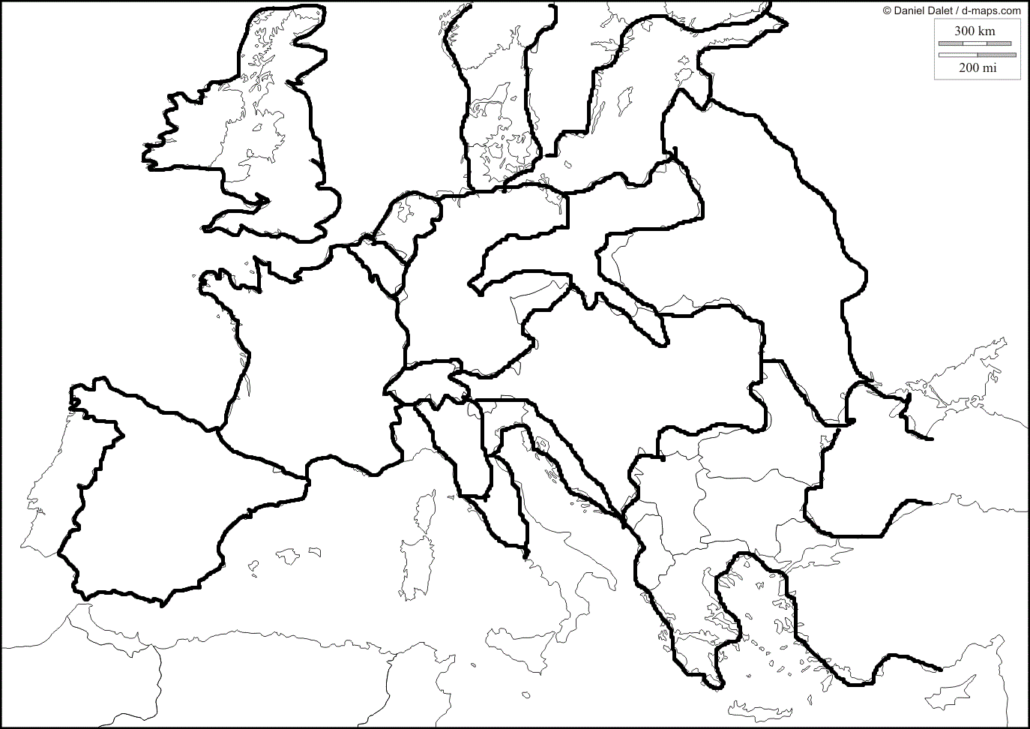 | 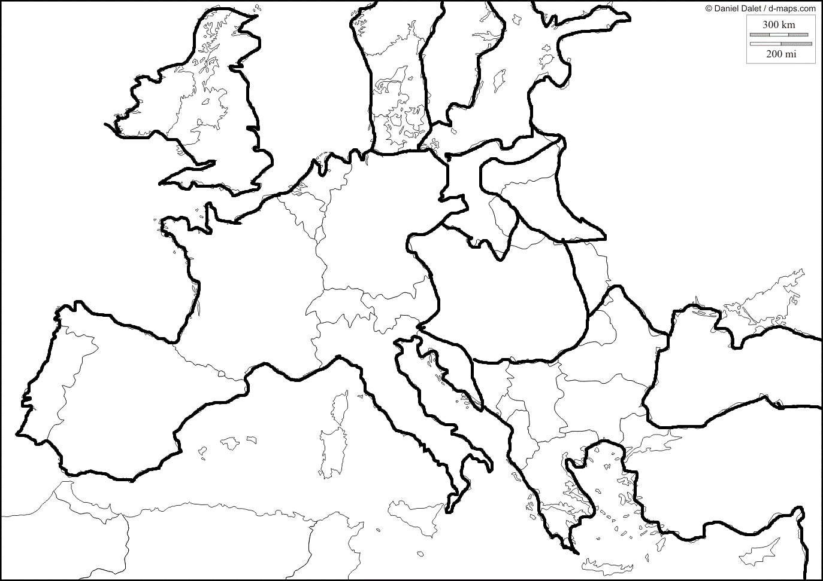

- Plan of Action
- The status of France
- What should the status of France be? Should they be punished? If so, how? If not, why not?
- Future of dispossessed dynasties
- What about all those thrones that Napoleon took over during his conquest? Should they be returned?
- Response to liberal and national attitudes sweeping the continent
- New political boundaries
- Compensation
- Balance of Power

- 1848
- Effects of the Congress
- France
- Italy and Germany
- Great Britain

- Conclusion
- The rise of nationalism was a powerful force behind European politics during the 19th century.
- The Congress of Vienna attempted to restore Europe as it had been before the French Revolution and the Napoleonic conquests.
- The legacy of the Congress of Vienna include:
- “Balance of Power” doctrine
- Restoration of monarchs
- New political map of Europe
- Widespread demands for political rights led to revolutions (1848) and legislative actions in Europe.
- Unsuccessful revolutions of 1848 increased nationalistic tensions. (They weren’t going to stop fighting!)

Key Terms, Concepts, Events, People, and Places:
Politics | Nationalism | Conservatism | Liberalism
Congress of Vienna | Metternich | Holy Roman Empire | “Balance of Power” Doctrine
Louis XVIII | King Louis Philippe | Revolutions of 1848
Questions to Consider:
- How did nationalism and democracy influence national revolutions?
- How did the map of Europe change as a result of Napoleon? How did the Congress of Vienna change it again?
- Why was France surrounded by so many countries?
- What happened to the Holy Roman Empire?
- What was the significance of the Congress of Vienna?
- How were the attempts at political and social changes different in the United Kingdom than in continental Europe?

