Unit 7: The Industrial Revolution
Lesson 1
- Introduction
- Objective: Introduction to Industrialization
- SOL WHII.6f, 9a
- Do Now: You are trapped in a room with a scale, a five gallon container, a three gallon container, and a tub of water. You are told that the only way out is to measure out four gallons of water and place it on the scale. However, you may use the scale only once. If you get it wrong, you will be trapped in the room forever. How do you get four gallons?

- Cotton
- Agricultural Revolution
- How to make clothes
- Process
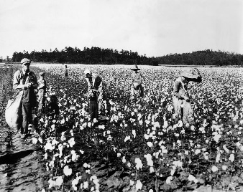 | 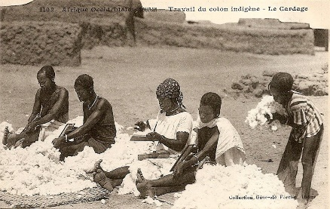 |  | 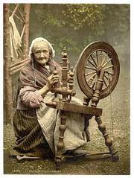
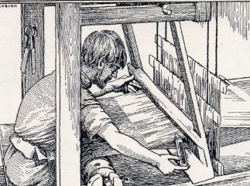

- Problems and Solutions
At first… |  | 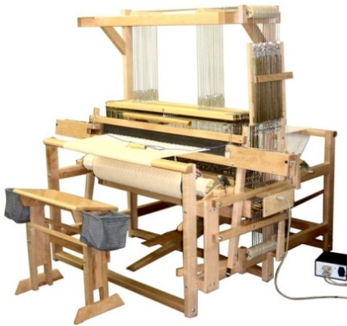
 | Problem: Weavers could not weave fast enough to keep up with the spinners. | Solution:
Then… | 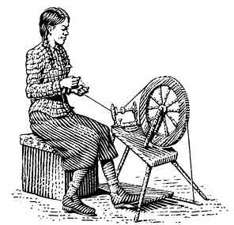 | 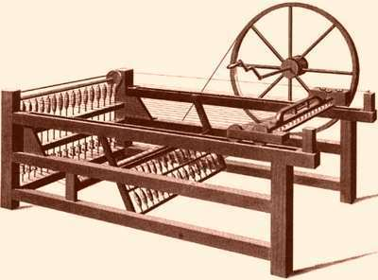
 | Problem: Spinners could not keep up with the weavers and their new machine. | Solution:
To be more efficient… | 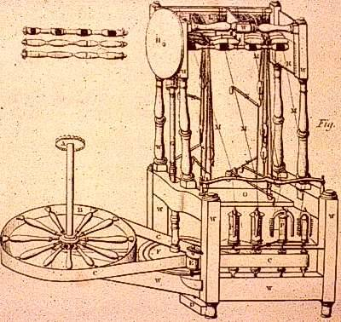 | 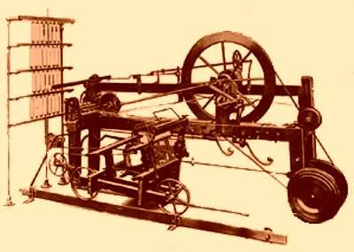
 | In 1769, | In 1779,
So… |  | 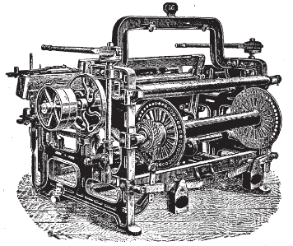
 | Problem: Spinners were outpacing weavers. | Solution:
Then… |  | 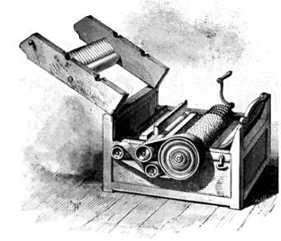
 | Problem: Spinners could not get cotton fast enough to keep up with the demand for cloth. Cotton came from the United States, but the demand for cotton exceeded the capability of the slave-based southern economy to create the supply. The best worker could not prepare more than 5 or 6 pounds of cotton per day because the problems of removing the seeds. | Solution:
Also… | 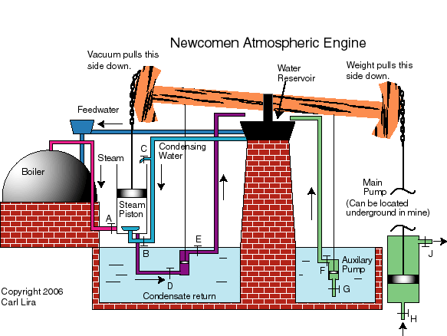 | 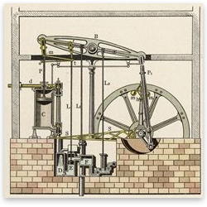
 | Problem: The textile industry became so large that it outgrew the possibilities of its power source; water power. The “atmospheric engine” (invented by Thomas Newcomen) was originally used in creating water power but it was inefficient. | Solution:

- Industrialization

- Iron Ore
- Mining
- Productivity
- Steel

- Capitalism
- Adam Smith
- The Wealth of Nations
- Defining Capitalism

- Why England?
- People and Government
- Social and Political Mobility
- Transportation
- No Wars

- Conclusion
- The Age of Reason witnessed inventions and innovations in technology that stimulated trade and transportation.
- The social and economic environment changed to accommodate an industrial society in which capitalism dictated the order of the day.
- Causes of the Industrial Revolution include:
- Advancements in technology in the production of cotton to cloth, and iron ore to steel.
- Capitalism.
- The Industrial Revolution began in England and spread to the rest of Western Europe and the United States.

Key Terms, Concepts, Events, People, and Places:
Agricultural Revolution | Cottage-Industry | John Kay | “flying shuttle”
James Hargreaves | “spinning jenny” | Richard Arkwright | “water frame”
Samuel Crompton | “water mule” | Edmund Cartwright | “power loom”
Eli Whitney | “cotton gin” | James Watt | Henry Bessemer
“Bessemer Process” | Steel | Industrial Revolution | Industrialization
Adam Smith | Capitalism | Laissez Faire | “The Invisible Hand”
Questions to Consider:
- What improved technologies were important to European economies?
- What role did cotton play in the Industrial Revolution? Explain.
- What role did iron ore play in the Industrial Revolution? Explain.
- What was the role of capitalism and market competition in the Industrial Revolution?
- Why did the Industrial Revolution originate in England (4)?

