Unit 7: The Industrial Revolution
Lesson 7
- Introduction
- Objective: Imperialism
- SOL WHII.9d and e
- Do Now: Color code the map below as you see it on the board.
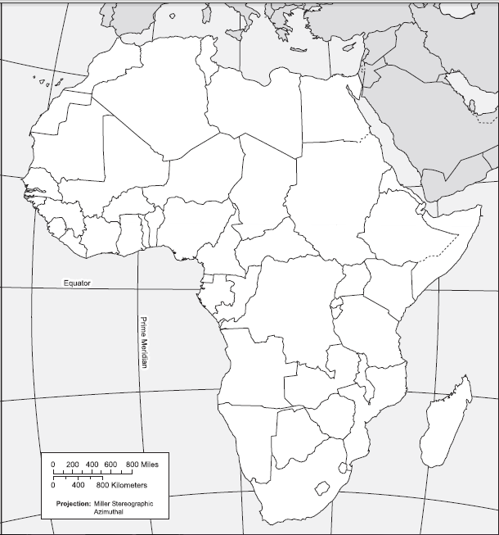
- Imperialism
- Define
- Why did European countries imperialize?
- Forms
- Colony
- Protectorate
- Sphere of Influence

- The Scramble for Africa
- Congress of Vienna
- The Suez Canal
- The Scramble

- Berlin Conference
- Conflict Among the European Nations?
- Conference

- Conclusion
- Industrial nations in Europe needed natural resources and markets to expand their economies.
- Nationalism motivated European nations to compete for colonial possessions.
- European economic, military, and political power forced colonized countries to trade on European terms.
- These nations competed to control Africa in order to secure their own economies and political success.

Key Terms, Concepts, Events, People, and Places:
Imperialism | Colony | Protectorate | Sphere of Influence
Congress of Vienna | “Balance of Power” Doctrine | Cape Colony | Suez Canal
Berlin Conference |  | “Occupation”
Questions to Consider:
- Why did European countries participate in imperialism and a race for colonies?
- How did Great Britain begin the “Scramble for Africa”?
- Why was a conference called in Berlin? What did it set?

