Unit 8: World War I
Lesson 1
- Introduction
- Objective: Causes of World War I
- SOL WHII.10a
- Do Now:
- Complete the map on the back.
- What do you think was the greatest cause of World War I? Be prepared to defend your answer!

MILITARISM | ALLIANCES | IMPERIALISM | NATIONALISM
- The Spark of World War I
- The Assassination
- The Ultimatum
- The Domino Effect
- Conclusion
- World War I (1914-1918) was caused by competition among industrial nations in Europe and a failure of diplomacy.
- Causes of World War I include:
- Militarism
- Alliances
- That divided Europe into competing camps
- Diplomatic failures
- Imperialism
- The quest for colonies
- Competition over colonies
- Nationalism
Key Terms, Concepts, Events, People, and Places:
Militarism | Alliances | Imperialism | Nationalism | Bismarck | Belgium Neutrality
Gavrilo Princip | The Black Hand | Kaiser Wilhelm I | Kaiser Wilhelm II | Archduke Ferdinand
Questions to Consider:
- Explain the MAIN causes of World War I. |  | - The assassination of Archduke Franz Ferdinand was the spark of the war but not the cause. Explain.

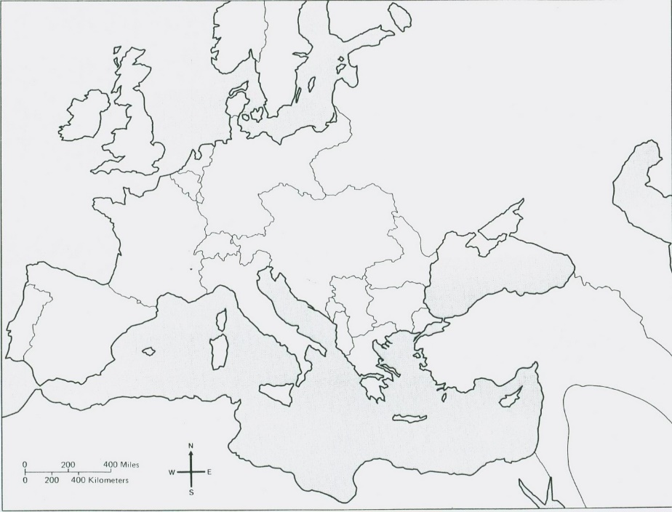 | Locate and label the following countries on the map:  Austria-Hungary  France  Germany  Great Britain  Italy  Russia  Ottoman Empire  Serbia  Morocco  Bosnia and Herzegovina
Document #1: Emile Zola, French writer, 1891, in James Joll, The Origins of the First World War, 1992
Would not the end of war be the end of humanity? War is life itself. Nothing exists in nature, is born, grown or multiplies except by combat. We must eat and be eaten so that the world may live. It is only warlike nations which have prospered; a nation dies as soon as it disarms. War is the school of discipline, sacrifice and courage.

Document #2: A French citizen, 1912, in James Joll, The Origins of the First World War, 1992
Would not the end of war be the end of humanity? War is life itself. Nothing exists in nature, is born, grown or multiplies except by combat. We must eat and be eaten so that the world may live. It is only warlike nations which have prospered; a nation dies as soon as it disarms. War is the school of discipline, sacrifice and courage.

Document #3: Bertrand Russell, British philosopher, in James Joll, The Origins of the First World War, 1992
I spent the evening (of August 3, 1914) walking round the streets, especially in the neighbourhood of Trafalgar Square, noticing cheering crowds, and making myself sensitive to the emotions of passerby. During this and the following days I discovered to my amazement that average men and women were delighted at the prospect of war.

Document #4: Kaiser Wilhelm II, to departing troops the first week of August, 1914, in Barbara W. Tuchman, The Guns of August, 1994
You will be home before the leaves have fallen from the trees.

Document #5: Russian National Anthem, 1833-1917
God Save the Tsar! God save the noble Tsar! Long may he live, in power, In happiness, In peace to reign! Dread of his enemies, Faith’s sure defender, God save the Tsar!

Document #6: “Rule Britannia” appeared first as a poem and was set to music in 1740. It has served since as an unofficial national anthem.
When Britain first at Heaven’s command, Arose from out the azure main; This was the charter of the land, And guardian angels sang this strain; Rule Britannia! Britannia, rule the waves; Britain never will be slaves. The nations no so blest as thee, Shall in their turns to tyrants fall; While thou shalt flourish great and free. The dread and envy of them all. Rule Britannia! Britannia, rule the waves; Britons never will be slaves.

Document #7: Newspaper run by Colonel Dragutin Dimitrevic, head of Serbian military intelligence and founder of the secret society, “Union or Death” (called “The Black Hand” by its opponents).
The war between Serbia and Austria… is inevitable. If Serbia wants to live in honor, she can only do this by war. This war is determined by our obligation to our traditions and the world of culture. This war derives from the duty of our race which will not permit itself to be assimilated. This war must bring about the eternal freedom of Serbia, of the South Slavs, of the Balkan peoples. Our whole race must stand together to halt the onslaught of these aliens from the north.

Document #8: Norman Rich, The Age of Nationalism and Reform, 1850-1890, Norton and Company, 1977
There was nothing inevitable about the triumph of the new nation-states… Nor is there anything inevitable about nationalism itself. People are not born with feelings of national self-consciousness… To overcome resistance… national governments… resorted to deliberate and intensive programs of indoctrination through state-controlled systems of education, compulsory military service, manipulation of the press, and all the other powers at the disposal of the modern state… The extraordinary feeling that some people seem to derive from the belief that they are members of a superior nation or race is undoubtedly one of the great appeals of modern nationalism. Another is the… belief that this superior nation was chosen by God or fate… This messianic quality of nationalism was eloquently expressed by the great Italian nationalist Giuseppe Mazzini (1805-1872). “Nationality,” he said, “is the role assigned by God to each people… so that the divine purpose may be realized in this world.”

Document #9: The Growth in Armaments, 1890-1914
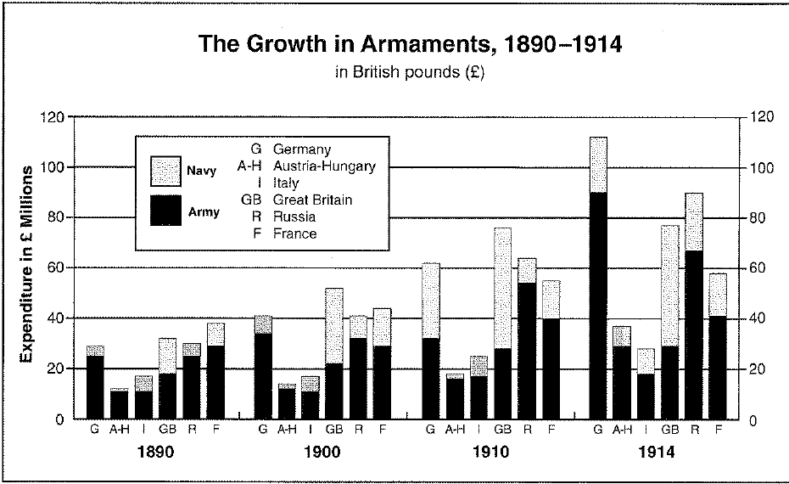
Document #10: “The Hammer or the Anvil,” 1899
Prince Bernhard von Bulow, German Chancellor, speech to the Reichstag, December 11, 1899 … we realize that without power, without a strong army and a strong navy, there can be no welfare for us. The means of fighting the battle for existence in this world without strong armaments on land and water, for a nation soon to count sixty millions, living in the centre of Europe and at the same time stretching out its economic feelers in all directions, have not yet been found. In the coming century the German nation will be either the hammer or the anvil.

Document #11: The British Octopus
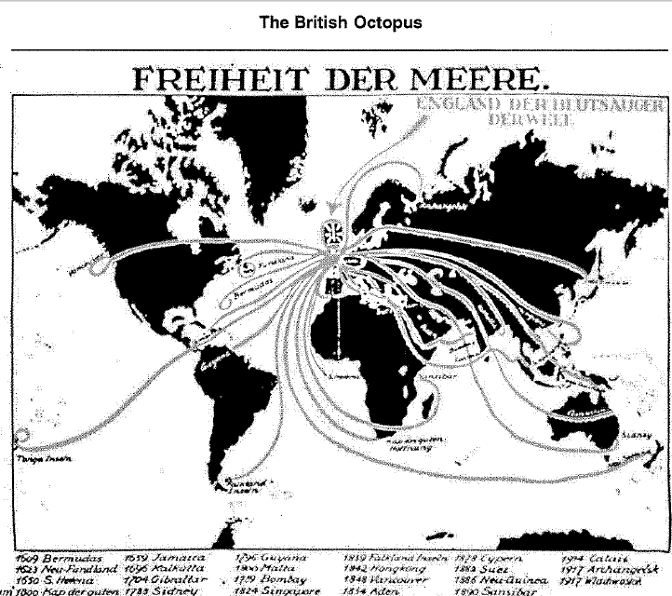

Document #12: “A Matter of Life and Death”
A steadily increasing… concern about national security gave rise to theories that a country’s survival as a great power depended on the extent of its territorial possessions and on the strategic advantages and economic resources such territories could provide. Colonies were deemed essential as sources of raw material for the manufacture of modern weapons, and as naval bases to protect trade routes and strategic supply tines. Moreover, the need to acquire such territories was growing more pressing with each passing day. Because the total amount of land in the world was limited, a state had to acquire as much territory as possible as quickly as possible while there was still territory left to take… Colonization, said the eminent French political economist Paul Leroy Beaulieu (1843-1916), had become for France “a matter of life and death: either France will become a great African power or in a century or two she will be no more than a secondary European power…”

