Unit 5: Age of Revolutions
Lesson 9
- Introduction
- Objective: Revolution in Latin America
- SOL WHII.7a, b, and d
- Do Now: Locate and label the following places on the map: Argentina, Brazil, Buenos Aires, Colombia, Cuba, Haiti, Havana, Lima, Mexico, Mexico City, Peru, and Sao Paulo.

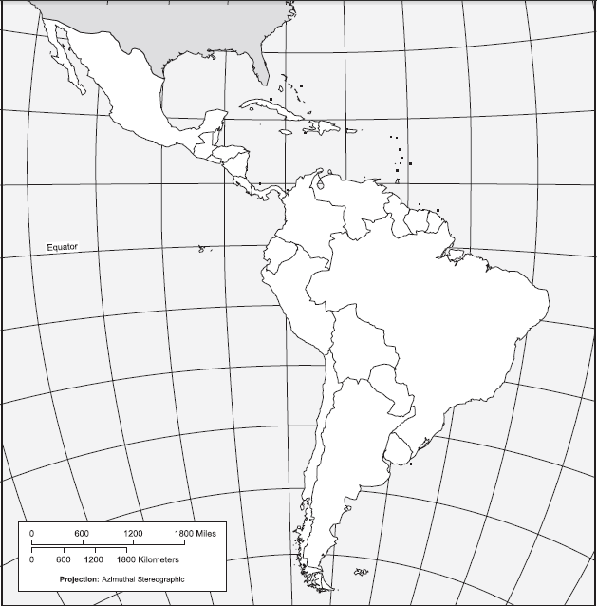

- The Colonial System
- Claims
- Characteristics
- Rigid Class Structure

- Haiti
- Colony
- Opportunity
- Toussaint L’Ouverture
- Independence

- Mexico
- Colony
- Opportunity
- Father Miguel Hidalgo
- Independence

- Colombia and Venezuela
- Colony
- Opportunity
- Simon Bolivar
- Independence

- Monroe Doctrine
- Issued
- Content

- Conclusion
- Conquistadores were given government authority by the crown, becoming viceroys.
- Spanish conquests in Latin America saw the rapid decline of the native population, and introduction of slaves from Africa.
- Latin American revolutions of the 19th century were influenced by the clash of European cultures in the development of governments and ruling powers.
- The American and French Revolutions took place in the late 1700s. Within 20 years, the ideas and examples of these revolutions influenced the people of Latin America to establish independent nations, most notably in Haiti and Mexico.
- The contributions of Toussaint L’Ouverture and Simon Bolivar led to the developments of independent states in Latin America in the 19th century.
- After the American Revolution, the United States wished to prevent foreign interference in America. The Monroe Doctrine, which was issued in 1823, alerted European powers that the American continent should not be considered for any future colonization.

Key Terms, Concepts, Events, People, and Places:
Argentina | Brazil | Buenos Aires | Columbia
Cuba | Haiti | Havana | Lima
Mexico City | Mexico | Peru | Sao Paulo
Viceroys | Conquistadores | Peninsulares | Creole
Mulattos | Mestizos | Haiti | Toussaint L’Ouverture
Haitian Revolution | “Black Napoleon” | Father Miguel Hidalgo | Simon Bolivar
Monroe Doctrine | James Monroe
Questions to Consider:
- What were the characteristics of the colonial system in Latin America in the 18th and 19th centuries?
- How did Spain and Portugal maintain control of their Latin American domains?
- How did the American and French Revolutions influence Latin American independence? Be specific!
- What were the contributions of Toussaint L’Ouverture and Simon Bolivar to revolutions in Latin America?
- How did the Monroe Doctrine impact revolutions in Latin America?

